Create and Resolve a Support Offering

Exercise 05.0

To: Self-Service User and IT Agent

From: Jennifer,Process Designer

Subject:Get familiar with SMA-X User Interface

Hello,

We just licensed the HP SMA-X offering for use within our company. It is time to get familiar with the Service Catalog Support offerings for end users and IT analysts. Focus on requesting a Support Offering from the Catalog.

Thanks,

Jennifer

Tasks to complete this exercise

Task 1: Access the Self-Service portal 2

Task 2: Request a Support Offering: Request Lync support 3

Task 4: IT Agent – Understanding Request User Interface 15

Task 5: IT Agent – Searching and Using Knowledge Articles to Solve Requests 25

Task 6: ESS User Interaction – Review and Reject Solution 32

Task 7: IT Agent – Review & Escalate Process 37

Task 8: IT Agent – Resolve the Request 41

Task 9: ESS User – Accept Solution and Close 44

Learning Check Questions 46

Challenge 46

Total Time to Complete: 40 mins

# Task 1: Access the Self-Service portal

1. Login into the ESS portal as amy.lopezmf.

# Task 2: Request a Support Offering: Request Lync support

In this Task, you will learn more navigational features of SMA-X and open a request to increase your email quota.

In the Welcome screen, Self-Service users can search specific topics or browse predefined offerings for service and support categories in the catalog. If a solution or catalog offering is not found, they can open a general support ticket. There are two methods to search for Support Catalog items: 1) navigate the catalog categories or 2) using Search topics. In the next steps, you’ll learn how to use both methods.

1. To search the Catalog by category, complete the following steps:
   1. From the Welcome page below, select **Productivity and Collaborating**.

A list of Productivity and Collaborating services and offerings are displayed.

* 1. In the Search bar type: **Lync**.
  2. Select **Request Lync support**. **Note**: the colored tag indicates this is a Support offering.  
       
     The Support offering **Request Lync support** is displayed. Do not submit this request, go to the next step to search by topic.

1. To Search by topic:
2. Click the **SMA-X** home button to return to the welcome page.
3. In **Search topics**, type the following: **I need support for lync**.
4. The results matching your topic are displayed. Select **Request Lync support**.
5. The Support offering is displayed. The text you entered into search are transferred automatically to the Request details description.
6. Add the following text to your Problem description: {enter your name}

Notice the right panel provides additional information that may help you solve your problem. Review the information before proceeding to the next step.

1. Click **Submit**.

Your Request # will be displayed.

You will alsoreceive an email indicating that your request was successful. A hyperlink to access this ticket is embedded in the email.

1. From Self-Service user interface, there are multiple ways to access your request.
2. In the user interface after you just submitted the request, click the link for your request to go directly to the support request ticket  
   
3. Or click on the upper right menu (three horizontal bars) and select Requests
4. Or click on the shortcut on the right side that says Your requests. .

In all of these options, your support request is displayed. If you are using a shared demo system, multiple requests with the same title 'Request Lync support' will be submitted so write down your Request Id here___________________________________ Note your request is in the Fulfillment phase. The meta phases for the request displayed for the end user are:

|  |  |
| --- | --- |
| Phase | Description |
| Classification | This phase indicates that the request needs additional review and triage by the IT Agent before it can be proceed to the next phase. |
| Fulfillment | This phase indicates that the request has been reviewed, classified and assigned to the appropriate support team. |
| Validation | This phase indicates that the IT Agent has solved the issue. In this phase, you will receive an email indicating that a solution has been found. The ticket is awaiting further action from you to review the request and either Accept or Reject the solution. |
| Done | This phase indicates that the request has been closed. |

1. Click **View Full details**.
2. In Request full screen, the end user can perform several actions.
3. Expand or hide details.
4. Mark as solved,
5. View Interaction history text displays communication between you and the IT Agent handling your request. You can enter text and click Post anytime during the ticket lifecycle.  
   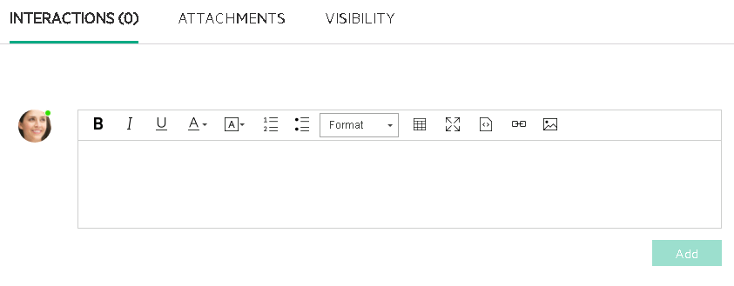

# Task 3: IT Agent – Understanding Request User Interface

In this task, you'll assign our new self-service ticket to yourself to work on as an IT Analyst.

1. In a separate browser, login as Jennifer.falconmf and go to the Agent UI.
2. From the Mega menu, select **Service Request Management**.
3. If your Request grid is not displaying a pre-defined view, add Request Views now. From the Requests view, click the **Edit Views** button and then select **All**.  
   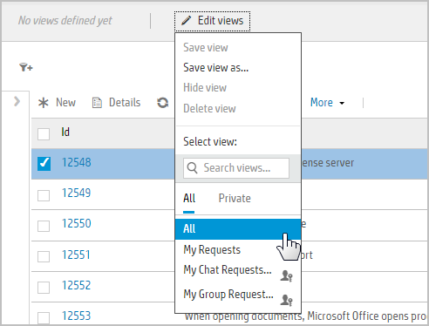
4. All requests will be displayed in the **Request list**.  
   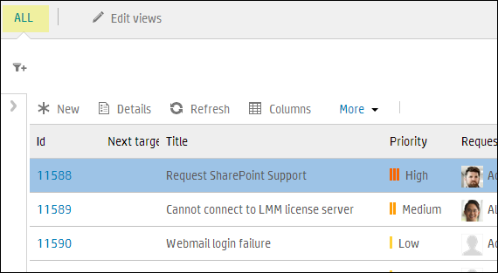
5. Click the Filter button  and select **Requested by**.  
   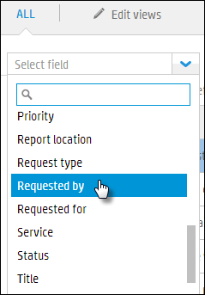
6. In the requested by input area and select **Lopezmf, Amy** from the drop-down list. The Request list will be updated with Requests logged by Amy.
7. Click the **Id** hyperlink for the Support Request requested juust created by Amy.

In the Actions Toolbar, options for Back, Forward, Backward, Save, Refresh, Start Discussion and More are displayed.   
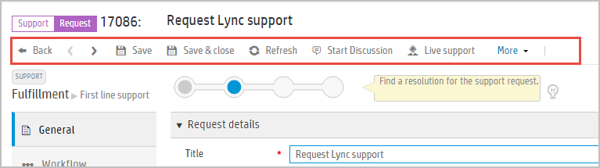

| Action | Description |
| --- | --- |
| Back | Return to the Request Inbox. |
| > | Navigate forward to the next Request in the list |
| < | Navigate backward to the previous Request in the list |
| Save | Save changes to the Request. |
| Save & close | Saves your changes to closed the Request from your screen. |
| Refresh | After a ticket auto-transition to the next phase, you can click Refresh to update the workflow. |
| Start discussion | Allows you to start a dialogue with another IT Person. You will use this feature later in the exercise with your class partner. |
| Live support | Starts the Live support area for this request. |
| More | The More option provides 2 options: 1) Send a copy of the Request to one or more co-worker by email or 2) Create a new Incident from this Request. |

1. This **Lifecycle Widget** section displays Meta Phase progress and the Lifecycle Widget. The Lifecycle Widget is used to manually progress to previous or future phases allowed in the workflow.   
   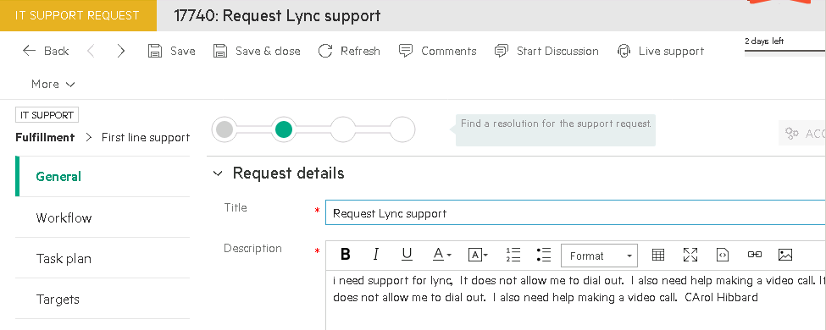
2. The Side Panel displays a list of current **User Questions** with similar text. This is important for assessing if other users may be experiences the same issue. This option only appears in Service Request Management. Click the vertical bar to collapse the section.  
   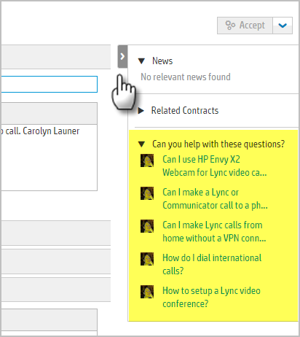
3. The Record tabs on the left panel display additional record areas. Click **Workflow**.  
   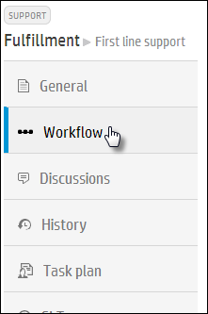
4. The workflow shows the Meta Phases and the phases for the lifecycle of this record. The Request automatically transitioned from the **Log** Phase to the **Classify** and then the **First line support** Phase automatically because conditions were met.   
   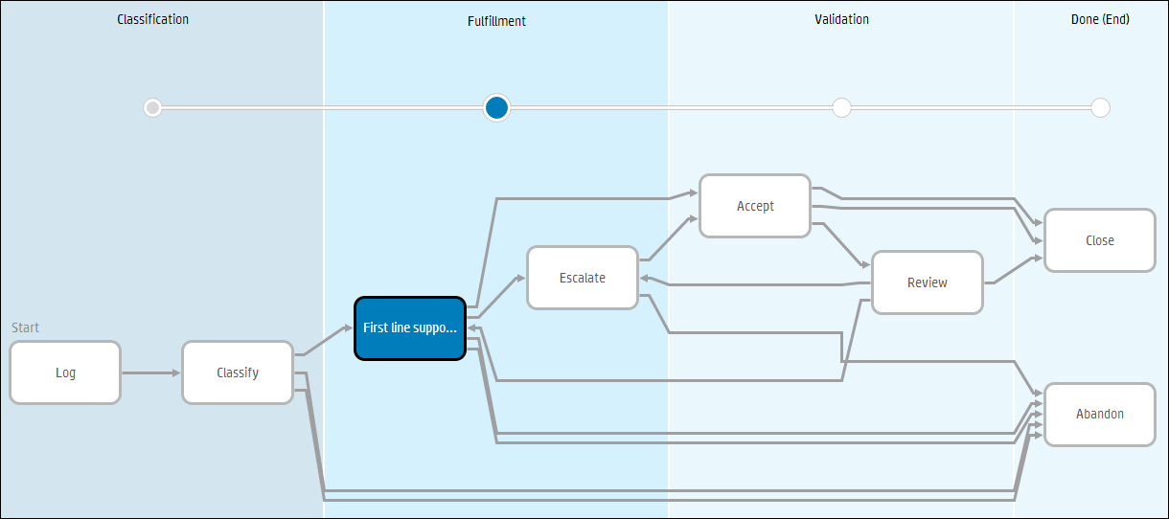
5. Click the **Discussions** tab. This section displays history information for system messages, All discussions, Live discussions and Comments both Public (visible to the end user) and Internal. You’ll come back to view and add Public and Internal Comments later in this exercise.  
   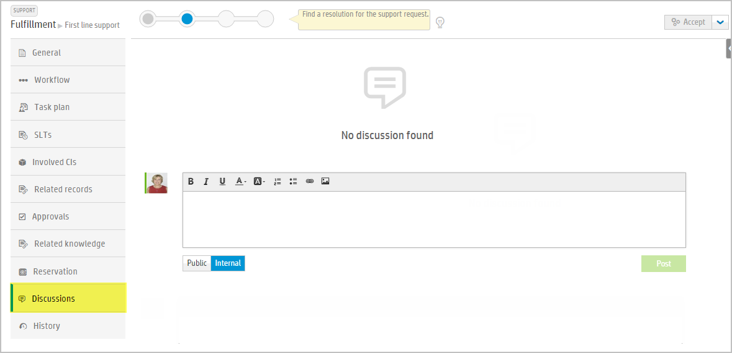
6. Click **General** tab and then the **Request** **Details** section.  
   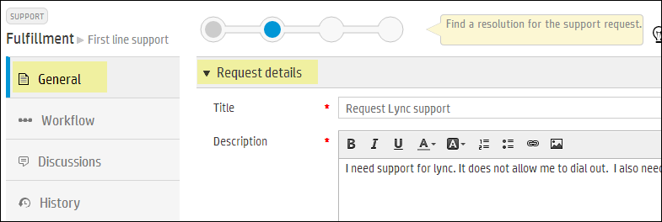
7. Click the show more link.  
   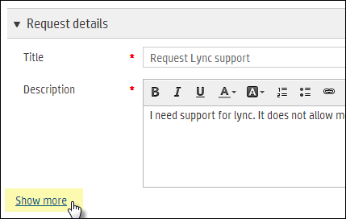
8. Set the **Expected resolution date** to tomorrow.
9. Set the **Expected resolution time** to 5:00 PM.
10. In the **Status** field, confirm the status is **In progress**.
11. In the **Description** of the ticket, you see that there are two issues that need to be resolved.   
    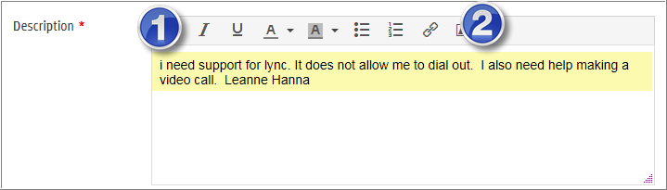
12. Collapse the **Request Details** section and expand the **Classification** section.  
    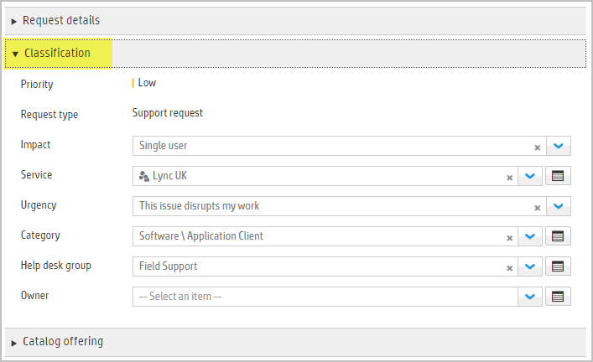
13. Scroll down to the Assignment sub-tab, and click in the **Owner** field and select your name (Jennifer) from the drop-down.  
    **Note**: Members of the Help desk group are listed in the Group Members section, other people are listed in All People section.   
    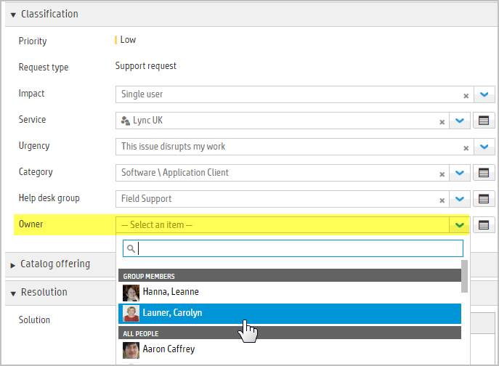  
      
    **Note**: If your name does not appear in the list of Group Members for the Help desk group, go to the Mega menu > **Administration** > **People** > **Groups** and add yourself to this group.
14. Click **Save**.

# Task 4: IT Agent – Searching and Using Knowledge Articles to Solve Requests

In this Task, you will learn how the IT Agent navigates and searches for Knowledge Articles to understand the powerful features in SMA-X available to quickly resolve issues and questions.

1. Click **General** tab. Collapse all sections except **Resolution**. The **Resolution** is already expanded. **Suggested solutions** hyperlink and **Find more solutions** button options are displayed. Let’s learn how to use search for more solutions.   
   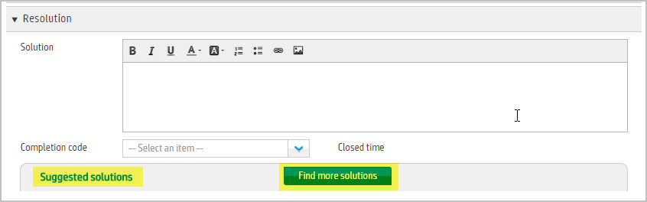
2. Click **Suggested solutions**.  
   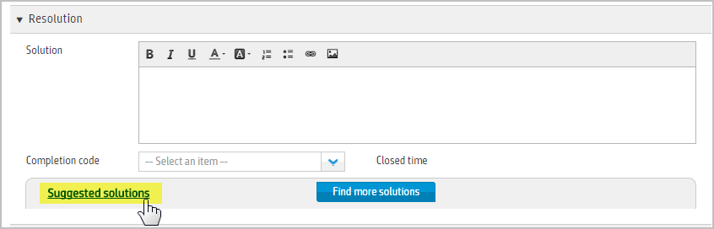

Three top matching solutions to the Title and Description are displayed.  
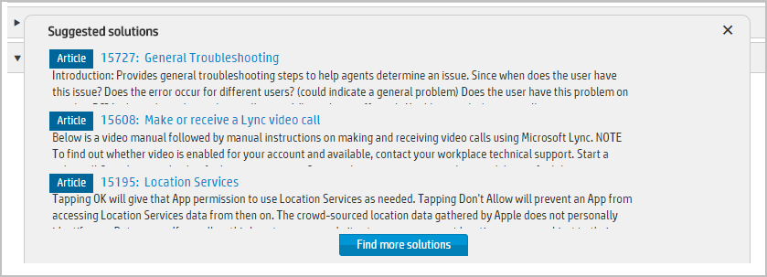

1. Use your cursor to hover over each of the **Suggested Solutions**. View details (or Edit) and Copy link to solution become active.  
   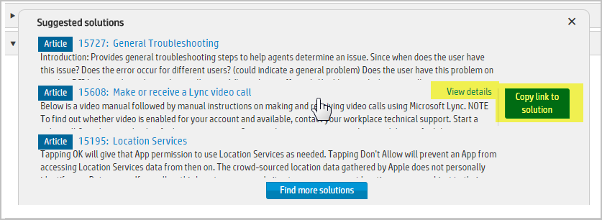
2. Click **Find more solutions**.  
   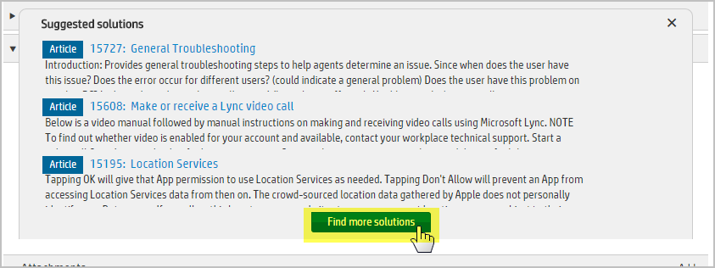
3. Search expands at the top of the screen with the ticket details at the bottom of the screen. You will see a list of 'All' entities searched which provide similar topics. Select **Make or receive a Lync video call**. A preview of the solution is displayed in the preview window on the right.   
   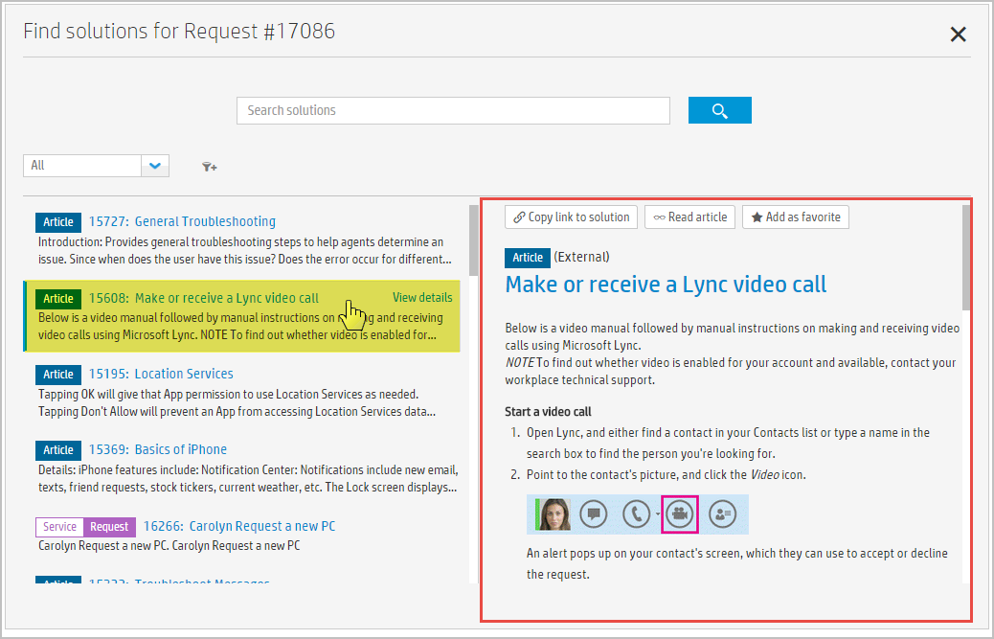
4. Click **Copy link to solution**.Note: the pop-up hover tip to use a keyboard short-cut for **C**opy to **S**olution.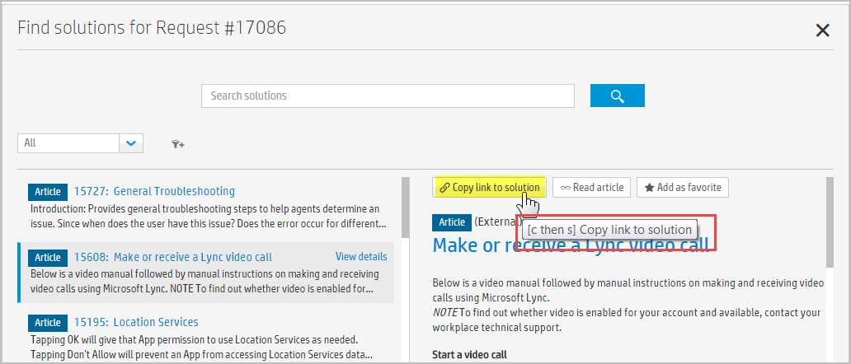
5. You are returned to the **Request Resolution** section. A description and a hyperlink have been filled into the Solution.   
   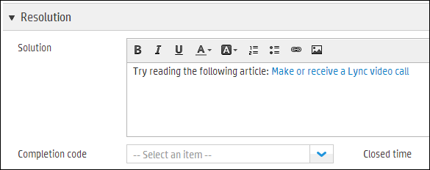
6. Append to the following text to the Solution: Click the Phone icon in communicator to make a call.  Let me know if the Knowledge Article helps.  
   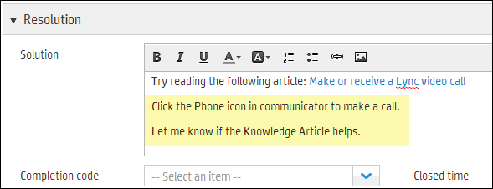
7. Click the drop-down arrow for **Completion Code**, and then select **Fulfilled offline**.  
   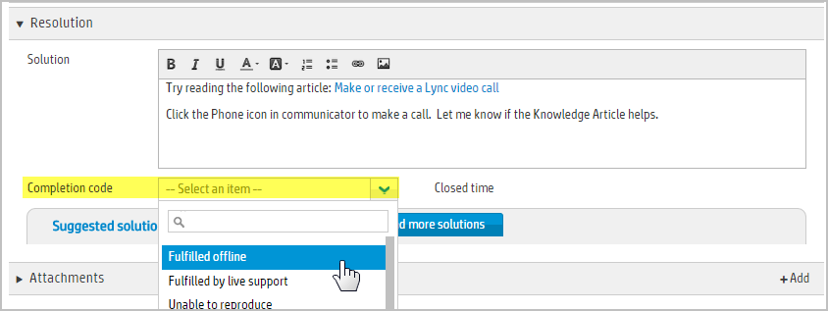
8. In the Action Toolbar, click **Save**.  
   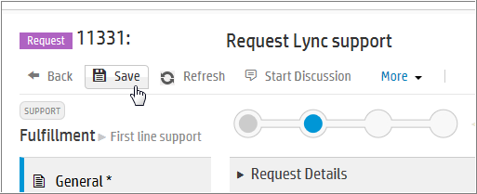
9. Amy will receive the following email message with hyperlinks to view the article, **Accept** or **Add comments**. You will receive a similar email. Do not click **Accept** just yet. You and your class partner will find instructions on how to reply to this message in the next task.   
   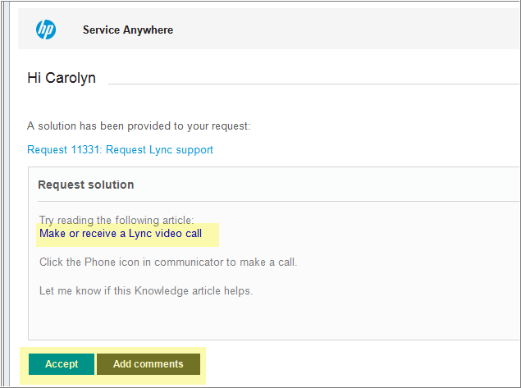
10. Click **Workflow** tab. The ticket has progressed to the **Accept** phase. When the request is in the **Accept** phase, it is waiting for action by the Requester. In the next Task, you will learn how to navigate the ESS user actions from the ESS portal.  
    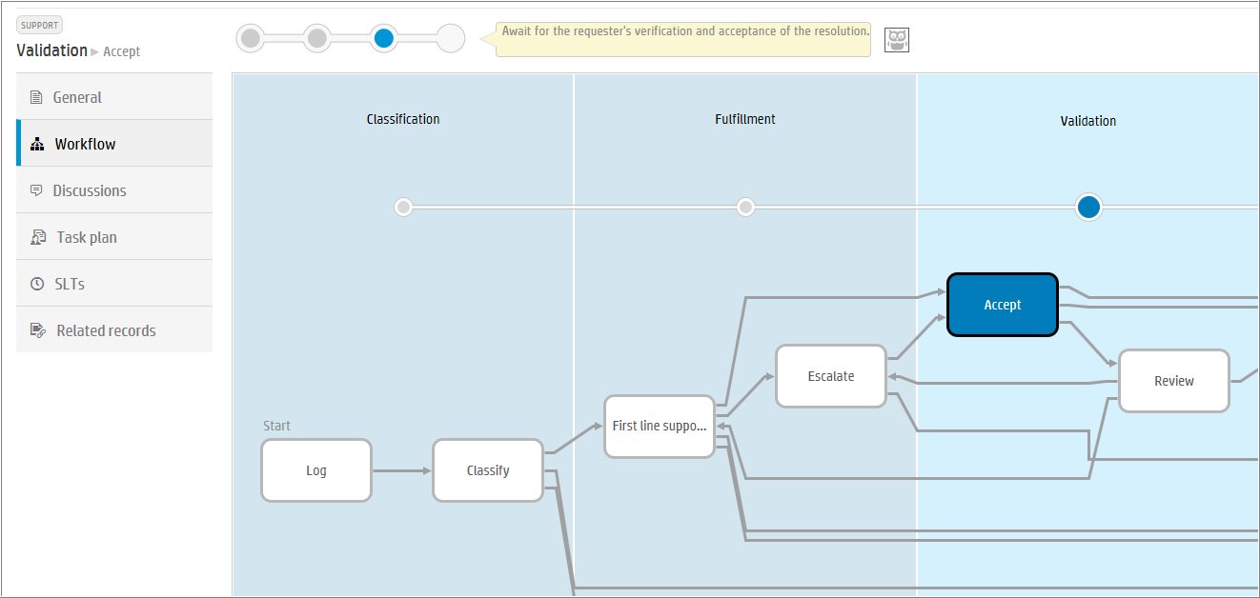
11. In the Action Toolbar, click **Back** to return to the **Request list**.  
    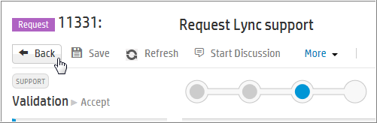

# Task 5: ESS User Interaction – Review and Reject Solution

In this Task, you will simulate exchanging dialogue about your request solution as the requester. After you receive an email from SMA-X with Subject: … I’ve a solution for your request nnnn, continue with the steps in this Task.

Note: all of these steps can be done in the email message or in the portal.

1. Navigate to Self-Service user interface by returning to your previously opened ta and open your request. If you have it open already, use F5 to get an updated view of the ticket.
2. You will be able to read the solution and have buttons to Accept or Reject the solution.
3. Click the hyperlink to read the suggested article.k Make or receive a Lync video call.   
   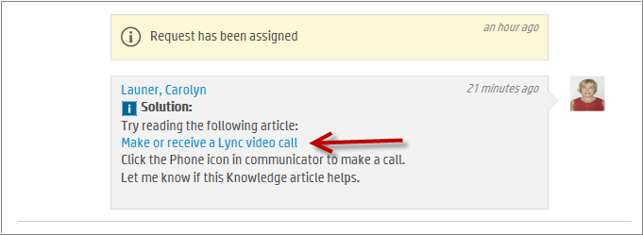

You are taken to the following Knowledge Article.  
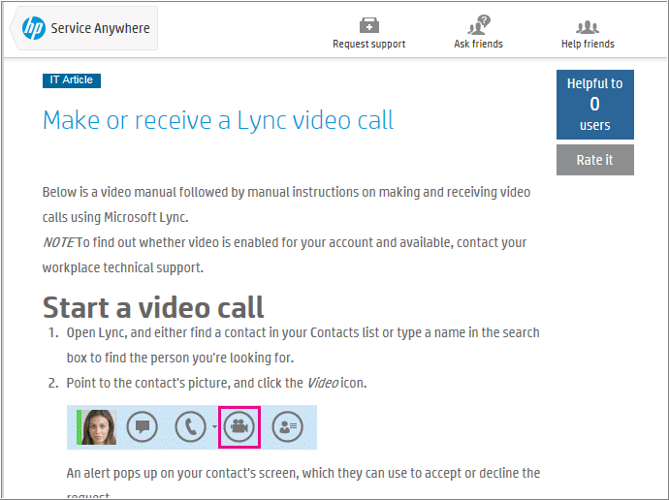

1. Click **Helpful** button in the upper right corner. The rating for the article will increase. Other students will be rating this article in their exercise. Your Helpful to user count may be different.  
   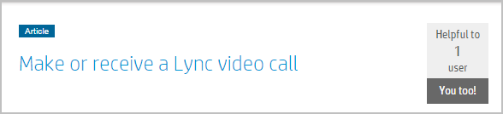
2. Click the back arrow in your browser window to return to your Request.  
   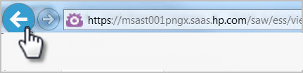
3. In the Comments box, type text: Thanks. The article is helpful, but I can’t find the Phone icon. Please help. Click **Add**.  
   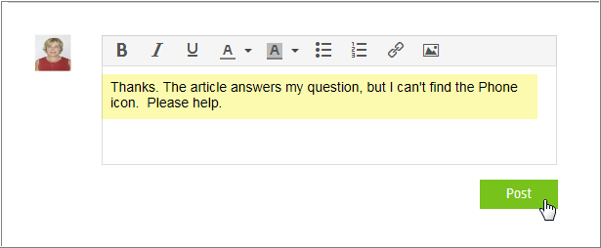  
   Your response will be added to the Interaction History.  
   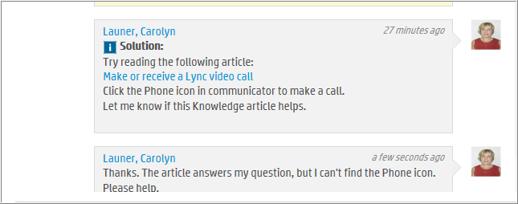

Add

1. Click **Reject**.  
   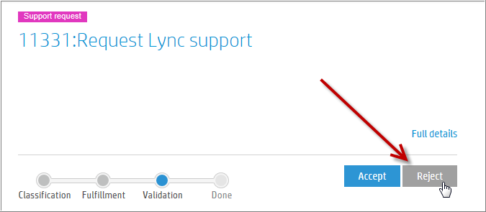
2. When a solution is rejected, the Owner will receive a similar email.   
   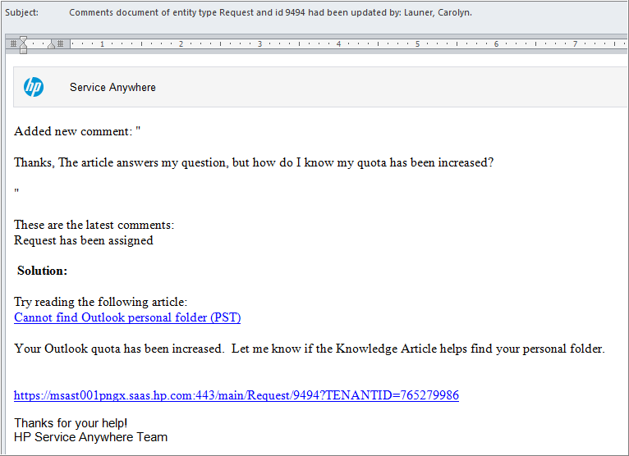

# Task 6: IT Agent – Review & Escalate Process

In this Task, you will review and escalate the request.   
  
**Important** **Note**: Do not confuse Escalate phase within the Request workflow with the option to select “Service Impact” checkbox in the Classification subtab. When the IT Agent uses the Escalate option in the Lifecycle Widget, the Fulfillment process remains with the IT Service Desk to seek additional help. Additional help can be: 1) assign the Request to someone with the required skillset to resolve the issue, or 2) start a conversation with someone who can assist with resolving the issue or 3) Create a new Incident from this Request.

However, if the “Service Impact” button is checked, a related Incident will be created and the Current Assignment field will change to ‘Incident”. The Incident owner will update the Incident and that information will be propagated to the related Request(s) fields.

1. In the IT Agent user interface, navigate to **Service Request** and to this request.

Click the **Workflow** tab. Because the solution was rejected, the ticket automatically transitions to the **Review** phase in the **Validation** Meta Phase.  
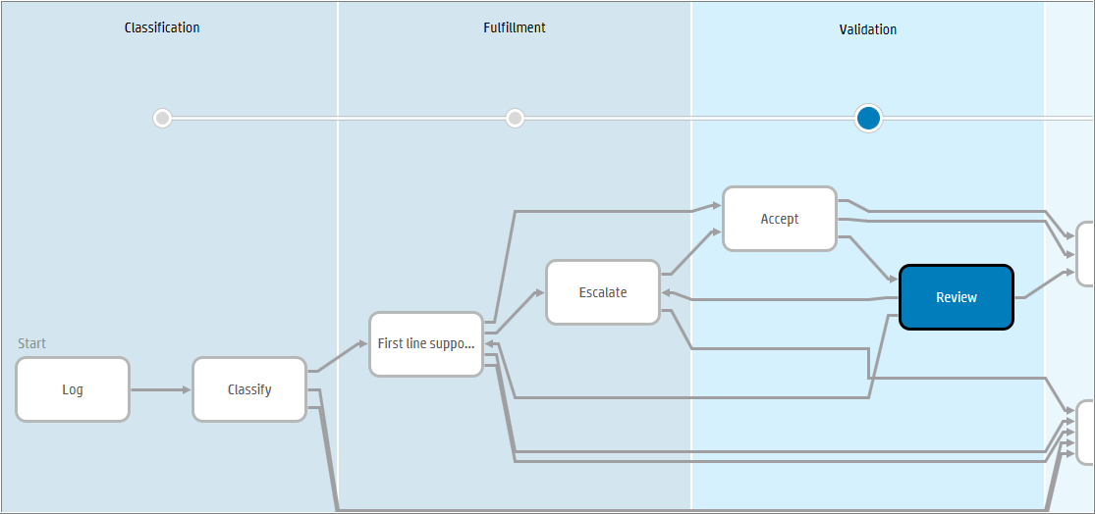

1. Click the **Discussions** tab. The Analyst can read why the solution was rejected.  
   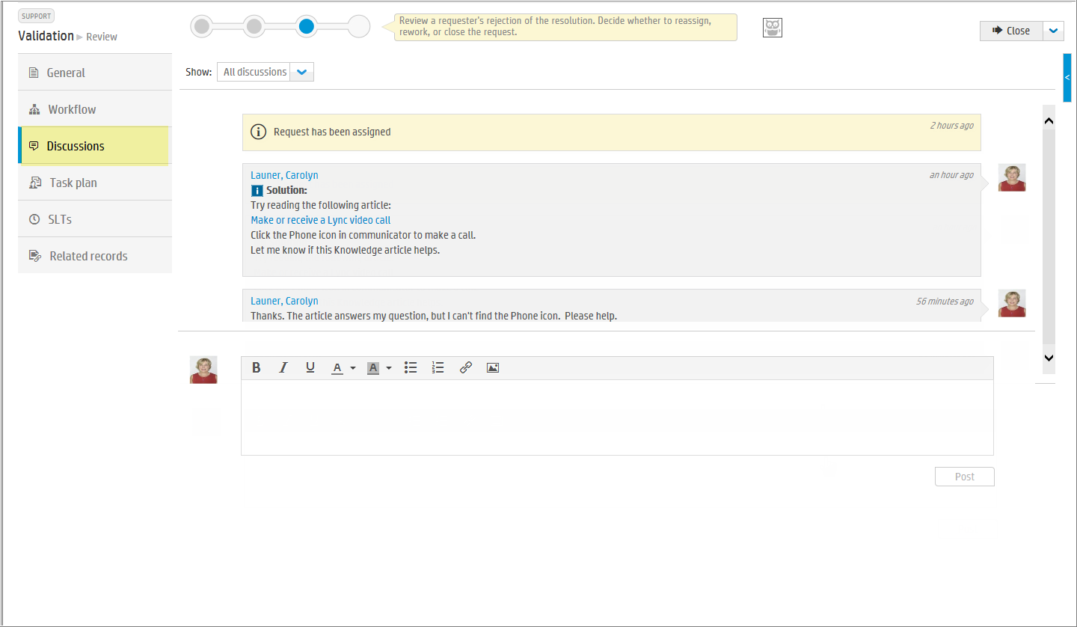
2. Click **Internal**, and then enter the following.  
   Escalating this request for additional assistance.  
   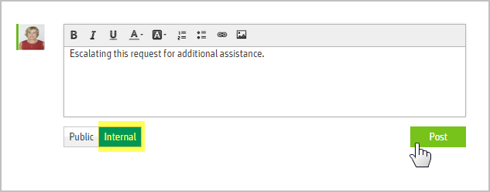  
   The Internal Comment is added.  
   Note: Use your mouse to hover over the lower right corner to edit or delete a comment.  
   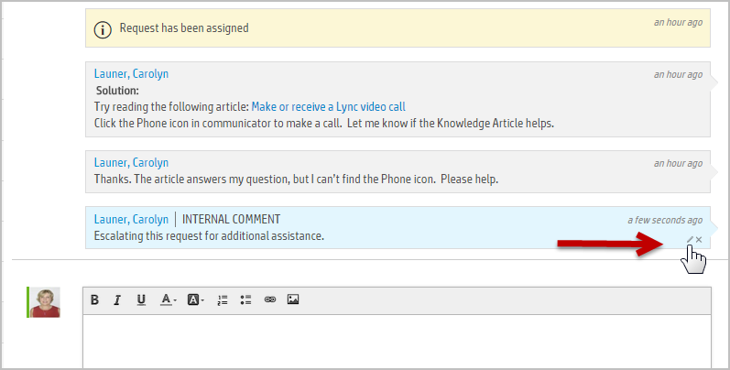

Add

1. To manually transition the Request to the **Escalate** phase, click the drop-down arrow in Lifecycle Widget, and then select **Escalate**. Alternatively, the IT Analyst could go to the First line support phase.  
   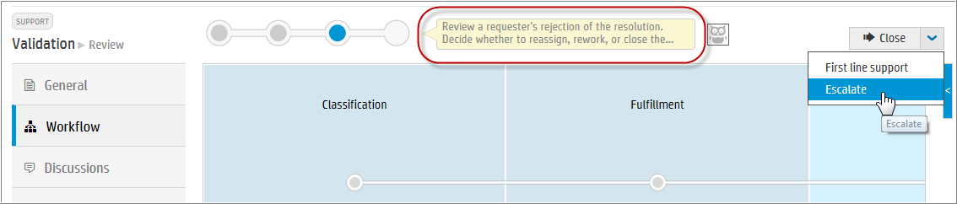
2. To confirm your action, click **Save**.  
   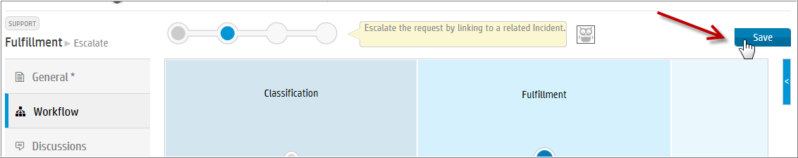
3. Click the **Workflow** tab. The Request is now in the **Escalate** phase in the **Fulfillment** Meta Phase. At this point in the workflow, the request can be resolved by reassigning to another group or person, starting a discussion requesting support or other processes.  
   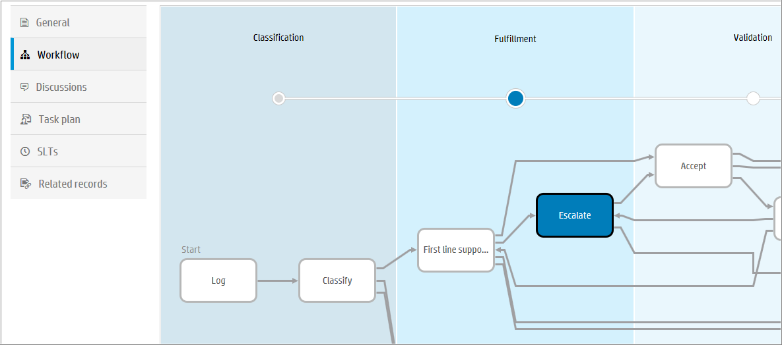

Please continue with the next Task. In the next exercise, you'll learn more about Starting A Discussion with a SMA-X Agent or User to resolve a request.

# Task 7: IT Agent – Resolve the Request

1. Click the **General** tab, and then collapse the **Request details** and **Classification** sections of the Request. Expand **Resolution** section.   
   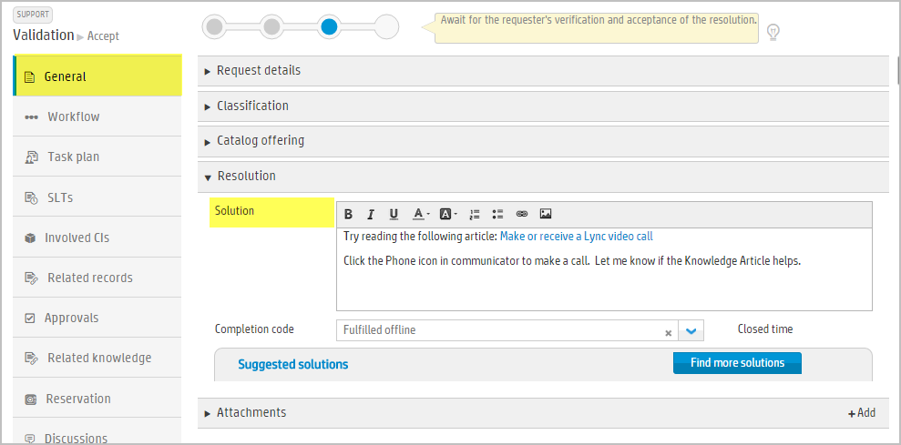
2. Append the following text to the Solution field and then select **Completion Code** to **Fulfilled offline**.   
     
   This request was escalated to second level support.  If your issue is corrected, please click Accept to close this request.  
   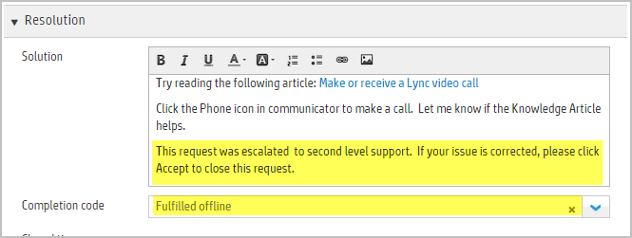

1. Click **Save**.  
   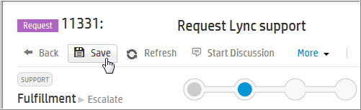
2. Click the **Workflow** tab to display the current phase of the Request.  
   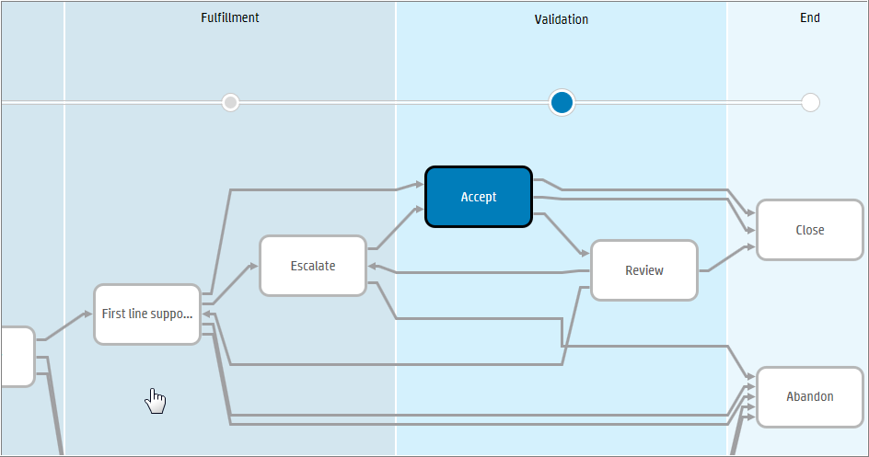

Amy will receive an email similar to the following:  
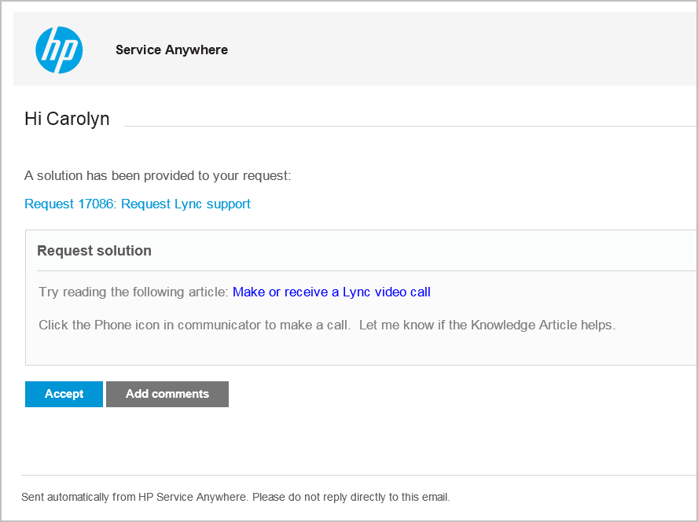

# Task 8: ESS User – Accept Solution and Close

In this task, you'll accept the solution provided by the IT Analyst to close the Request.

1. Return to Self-Service portal. Navigate to the **Request Lync Support** Request.
2. The request is in the **Validation** Meta Phase. Review the conversation history. Click **Accept**.  
     
   The Meta Phase will display **Done.**

# Learning Check Questions

1. What are the two types of Service Request records?
2. What two fields must have a value to automatically transition from First line support to Accept phase?
3. When a Request is in the Review phase, when would an IT Agent select First line support in the Lifecycle Widget instead of Escalate?

# Challenge

1. In the Agent UI, Open Global Search. Look for terms: office, SharePoint, database.
2. In the Request list, use the gear icon to create a view of High and Critical Support requests.